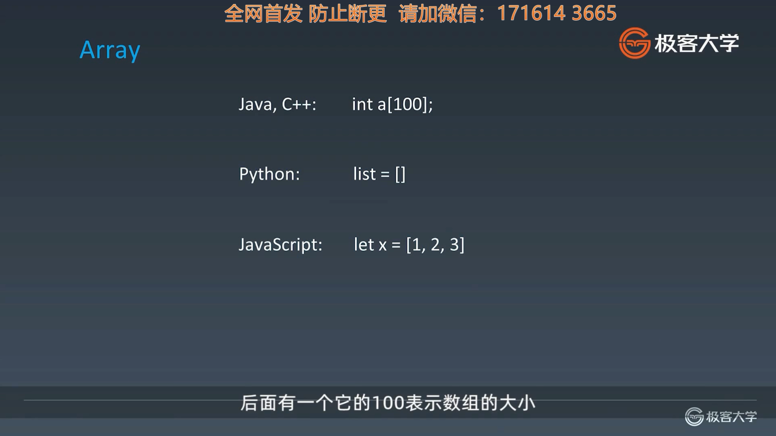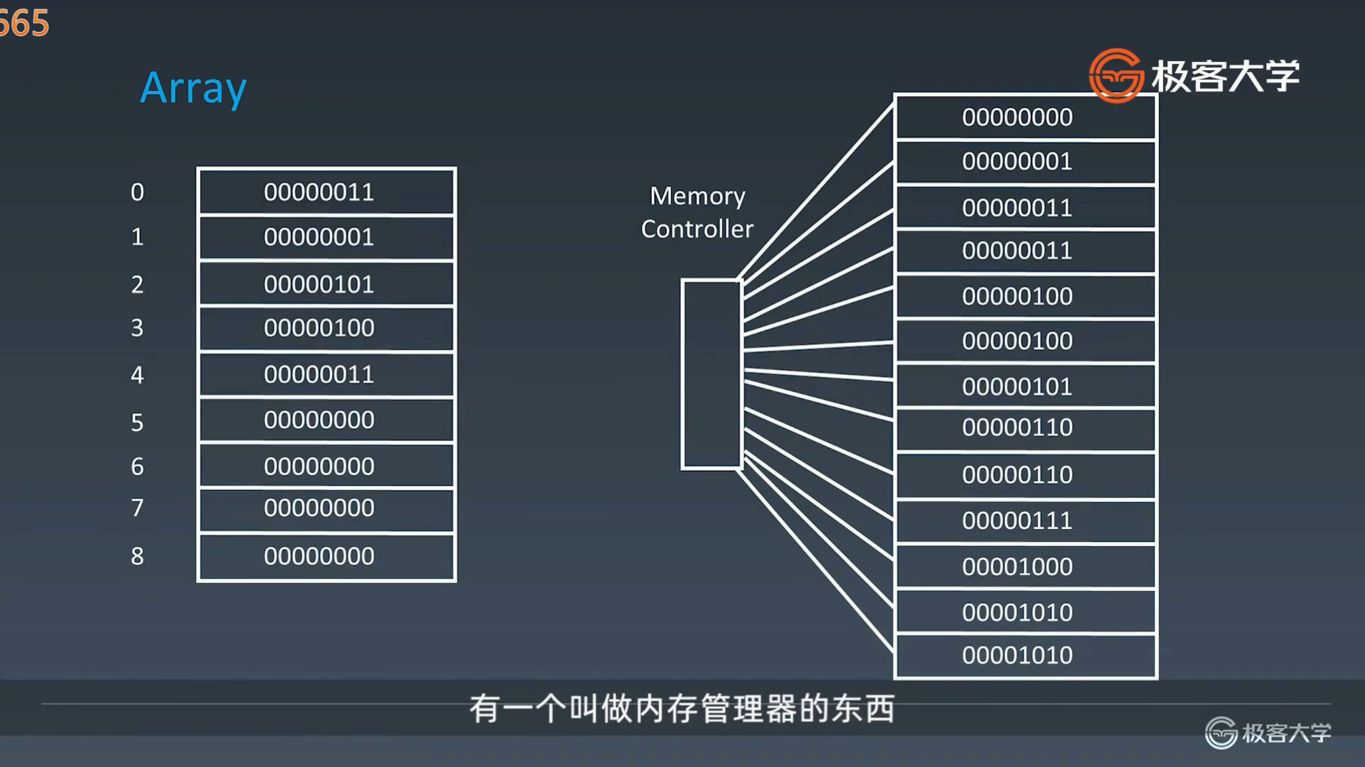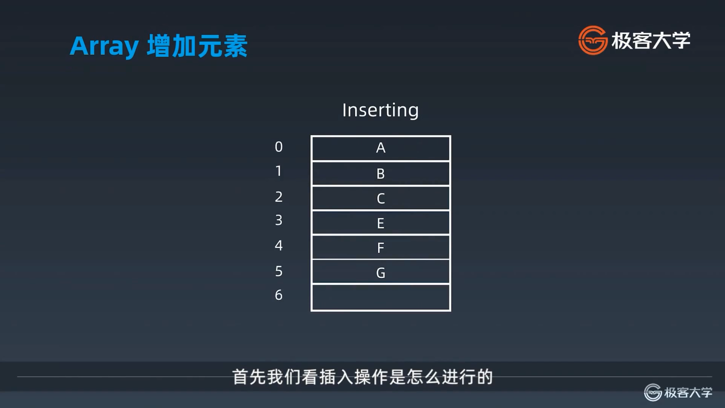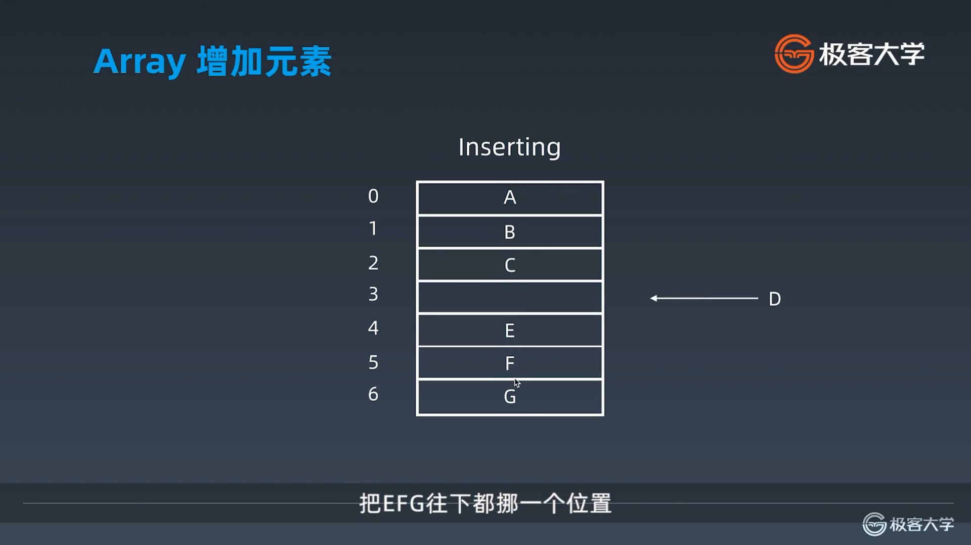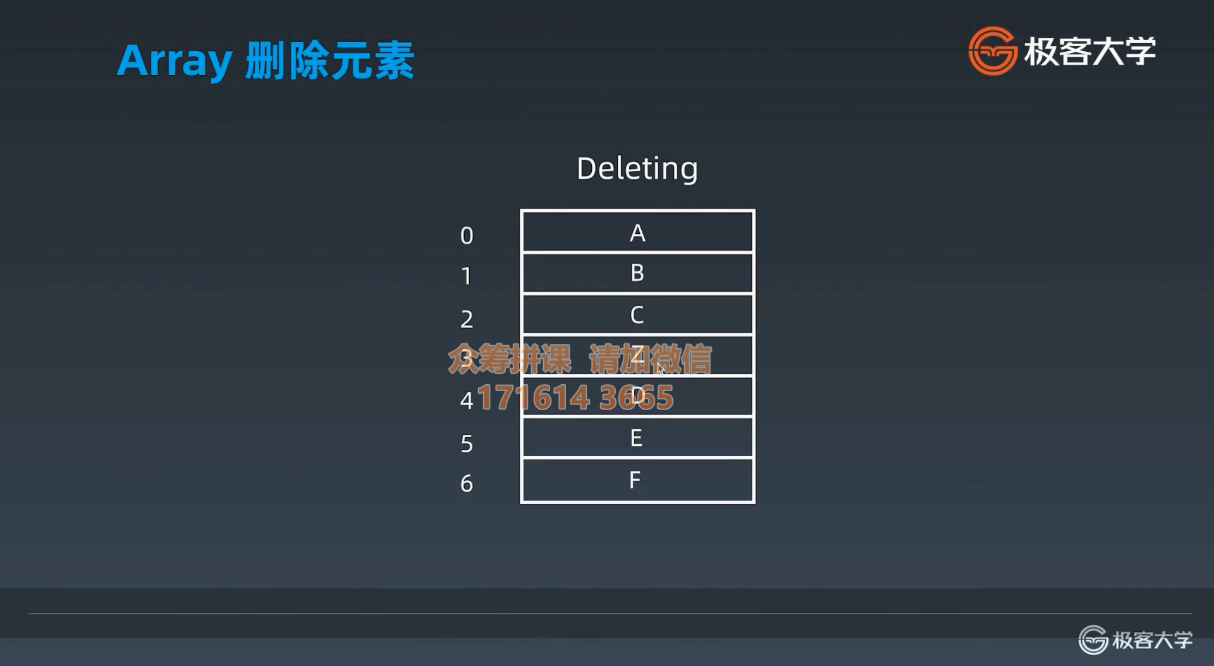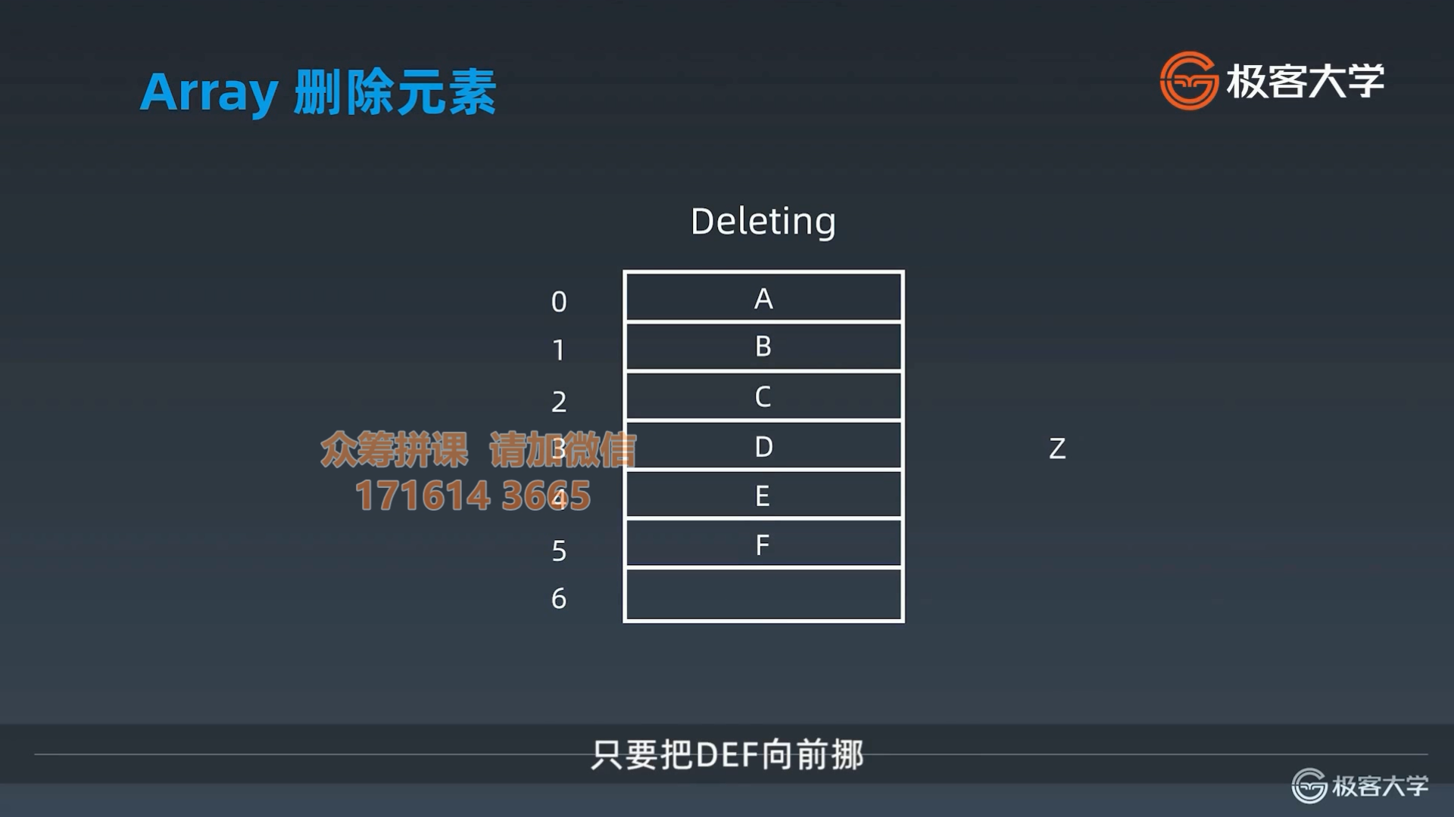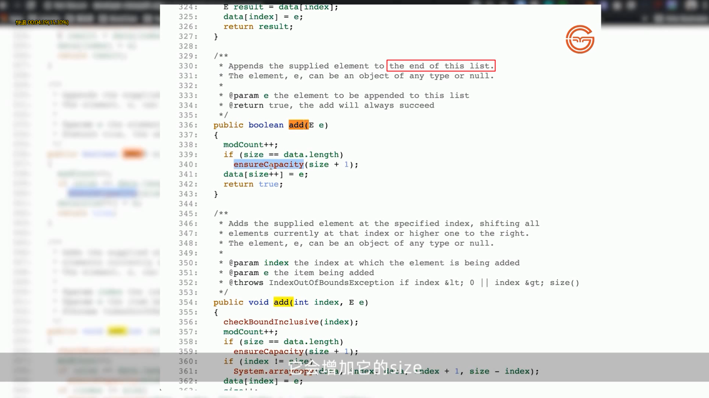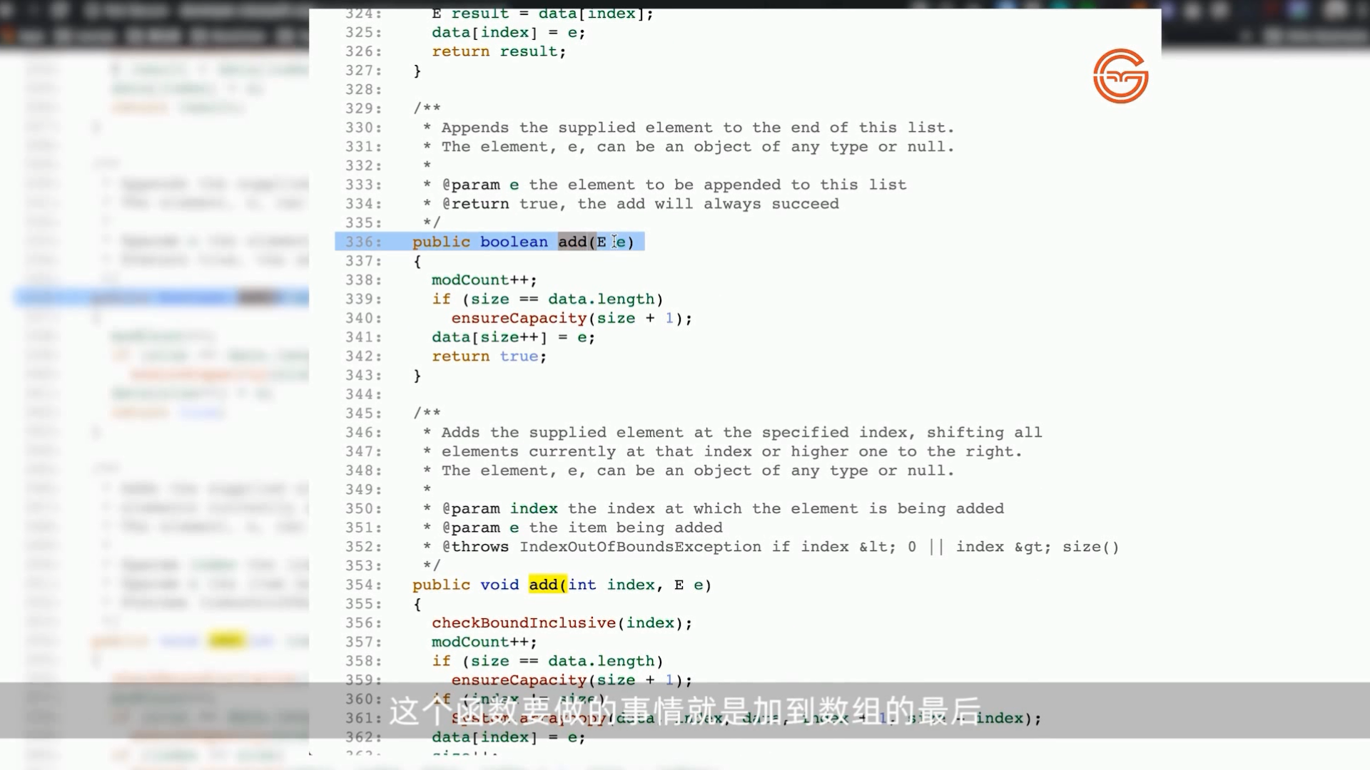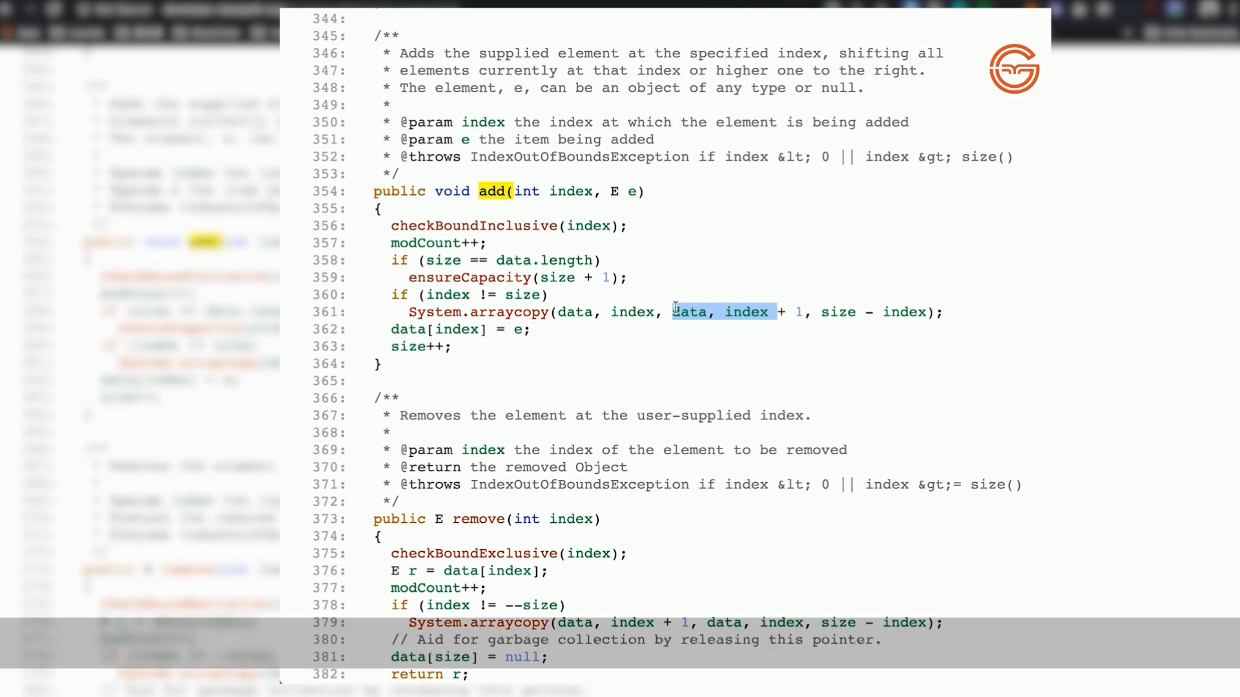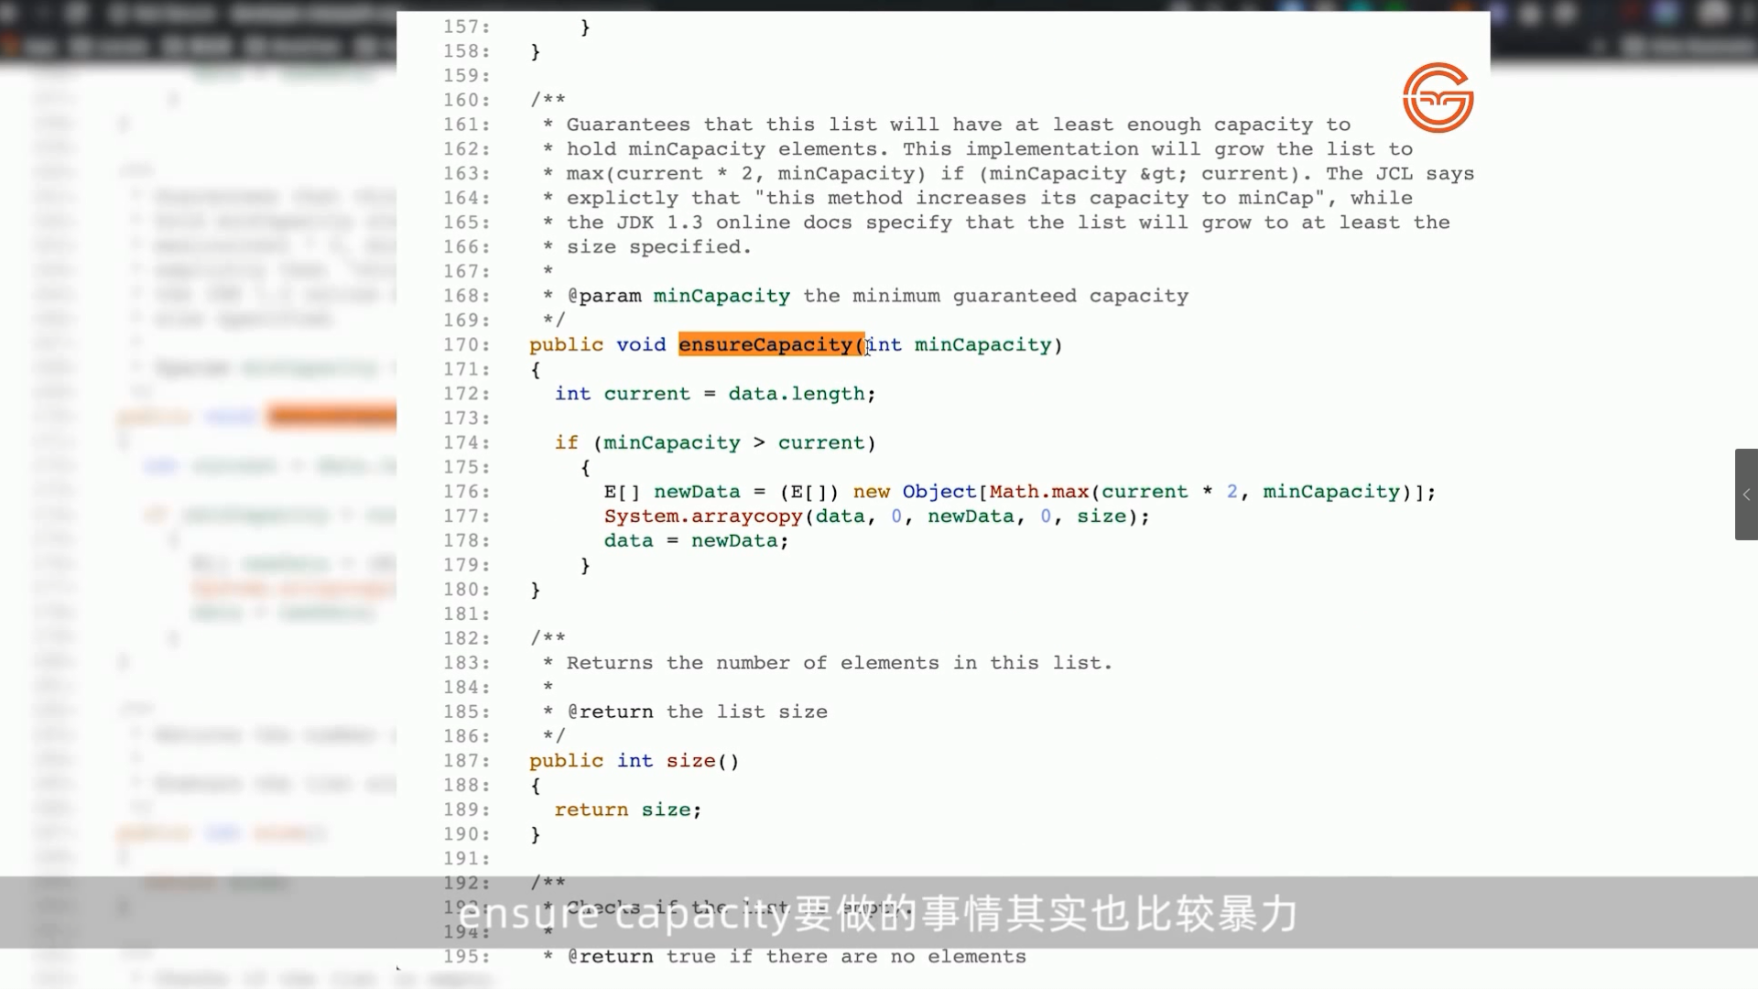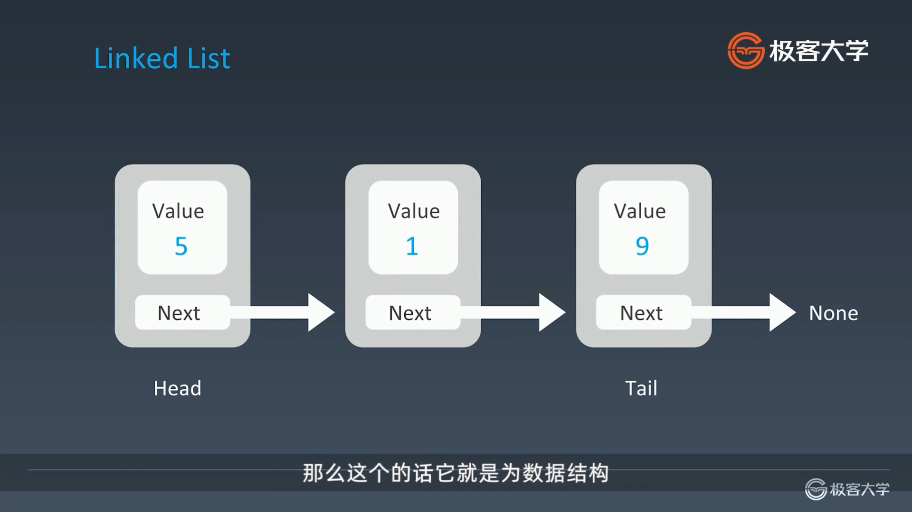

单链表、双向链表、循环链表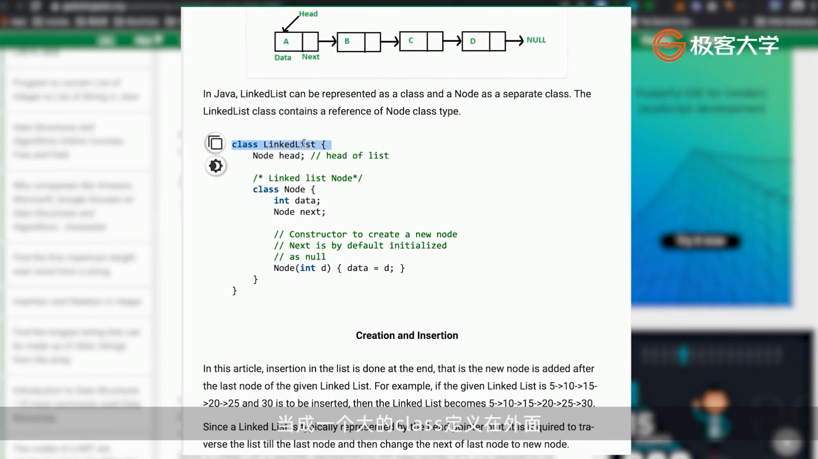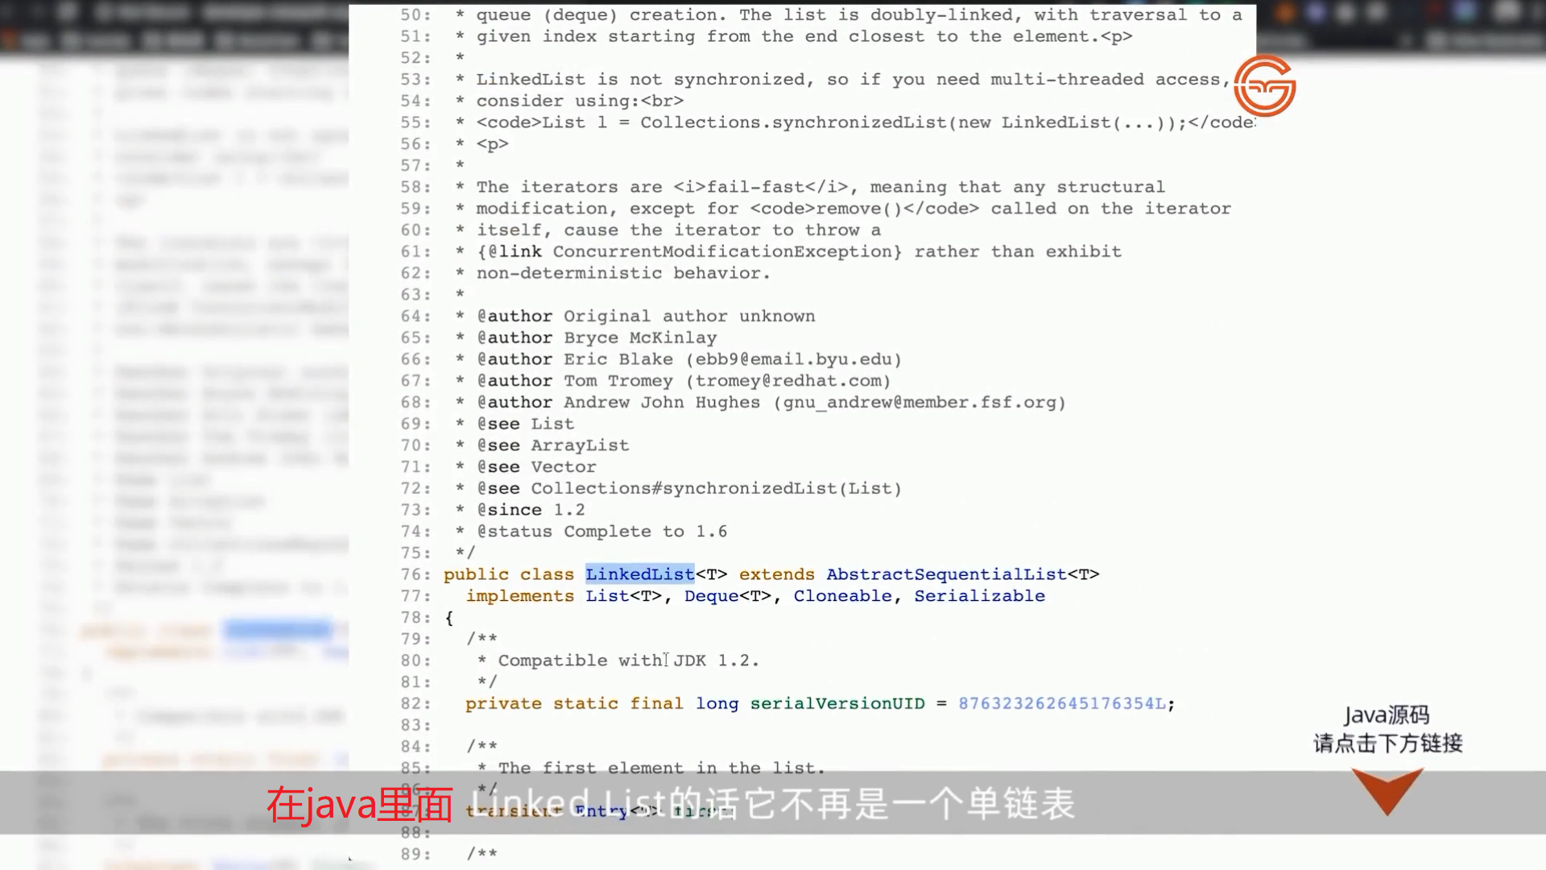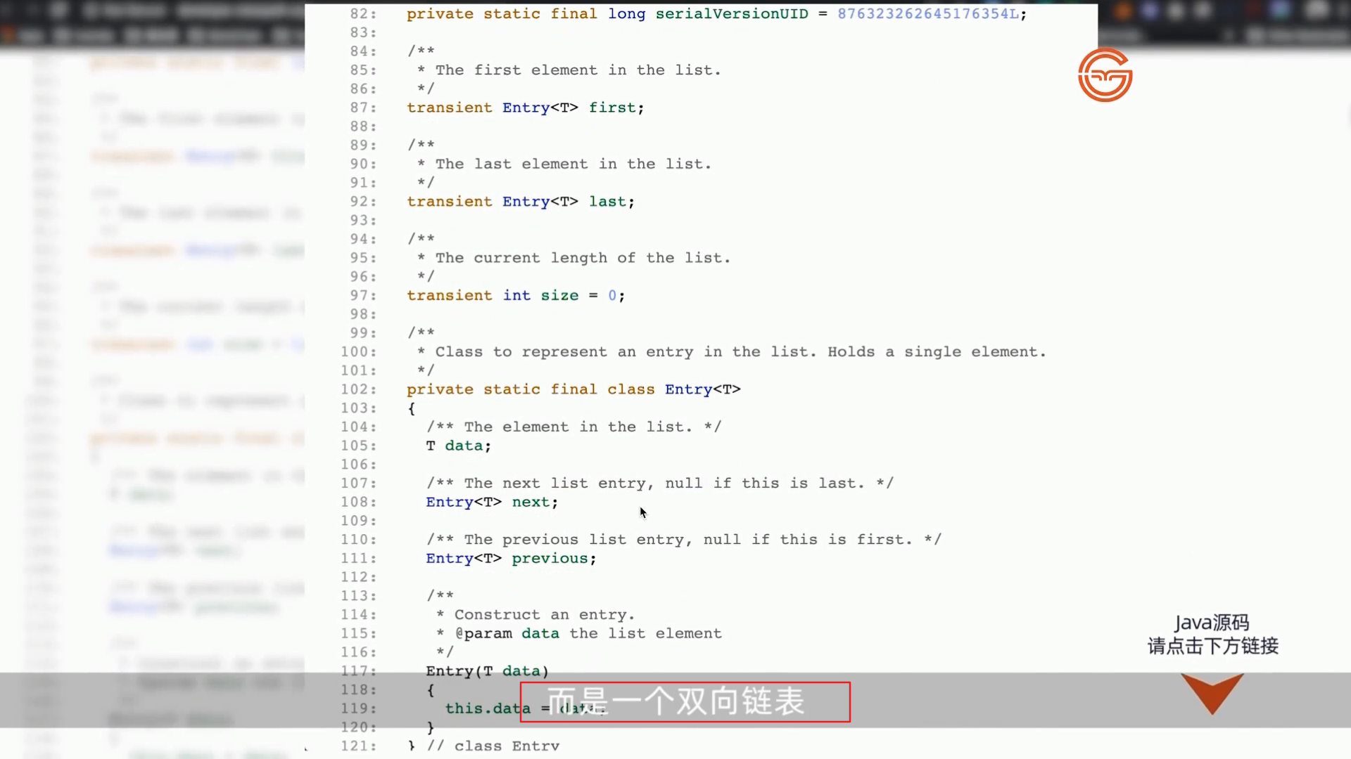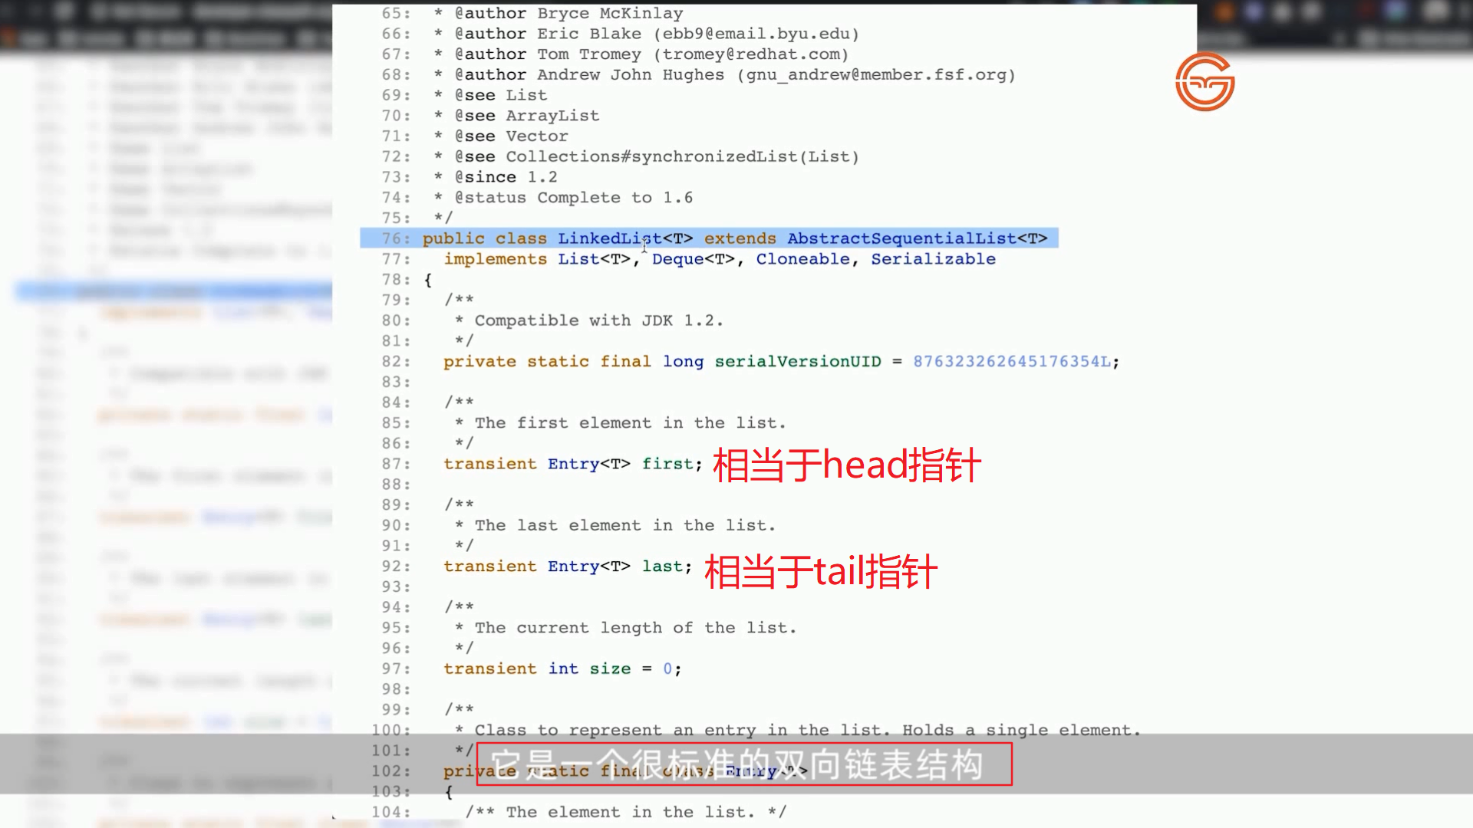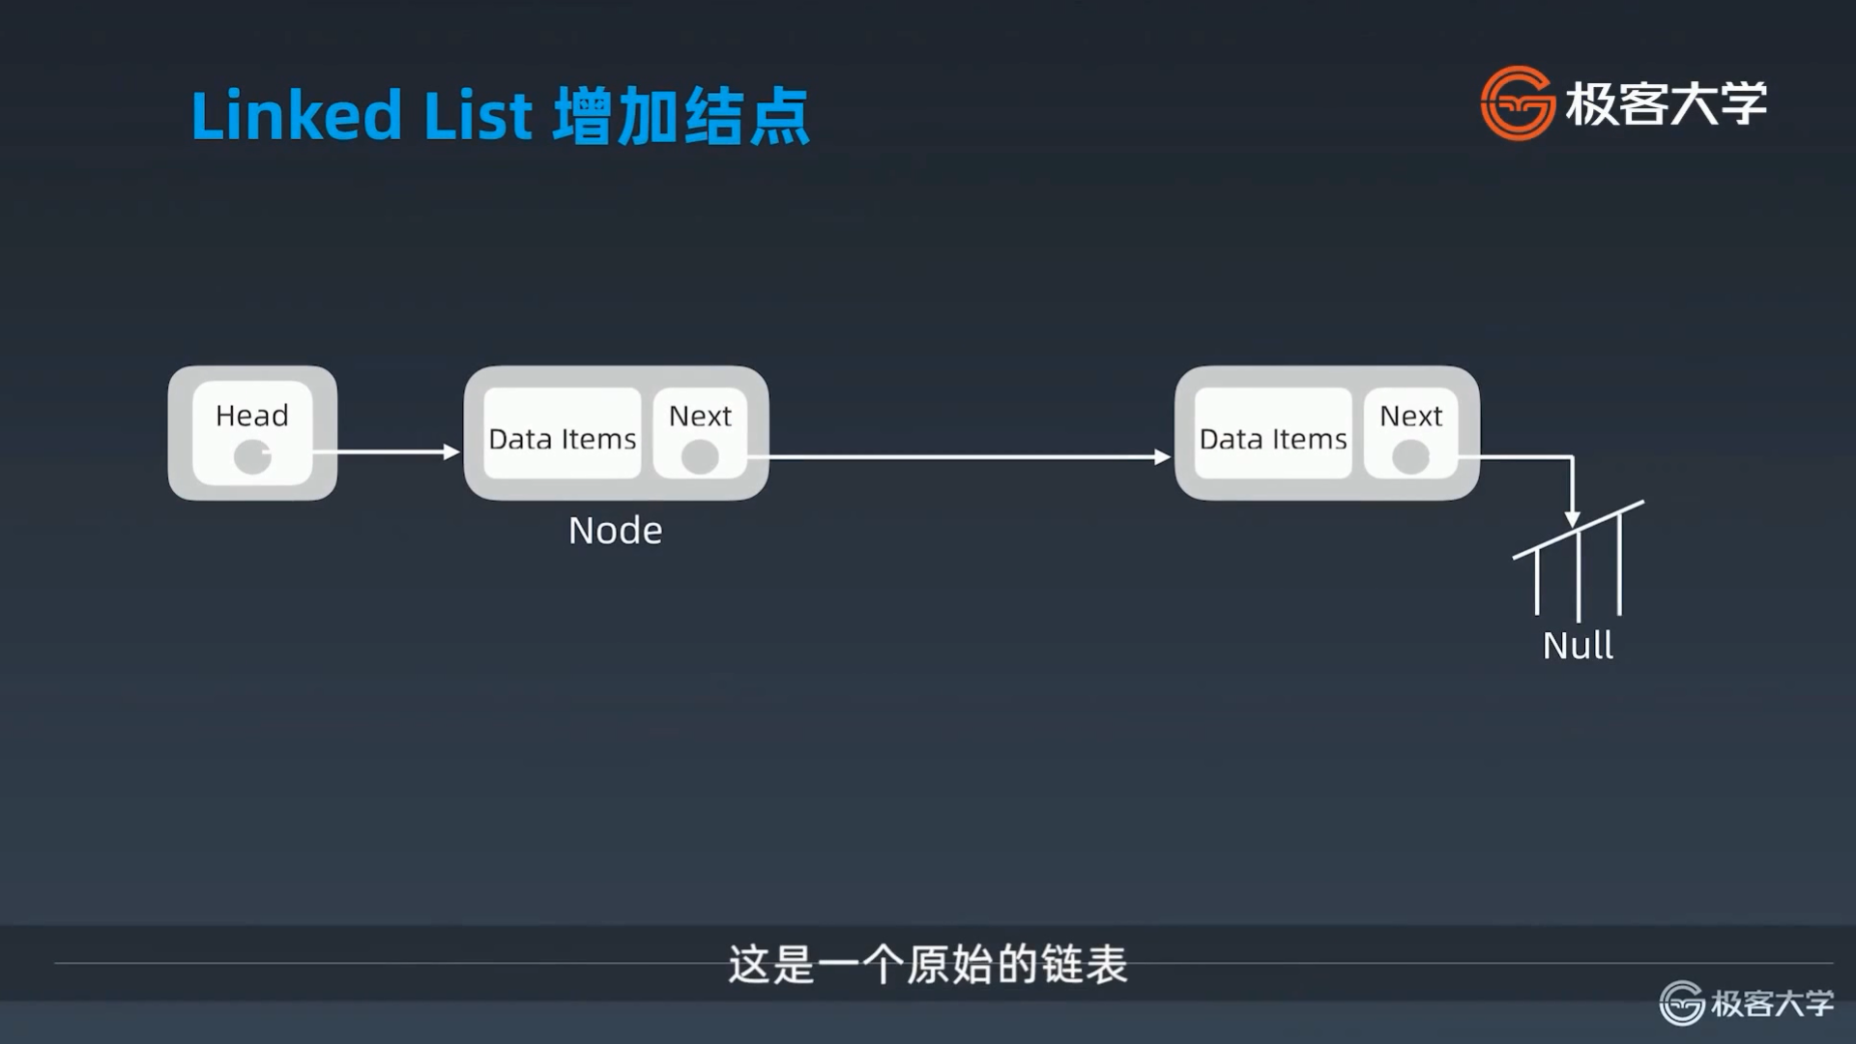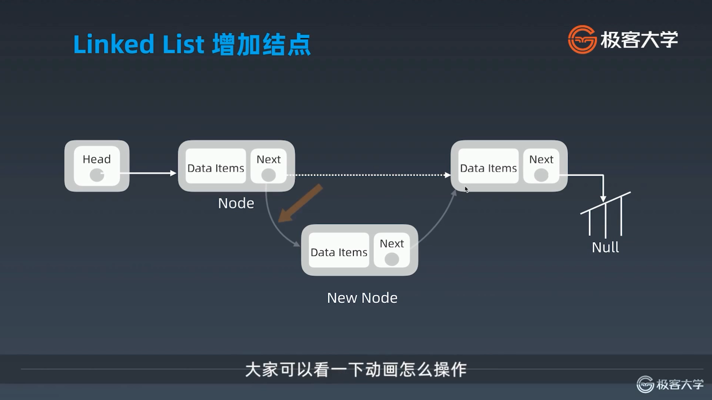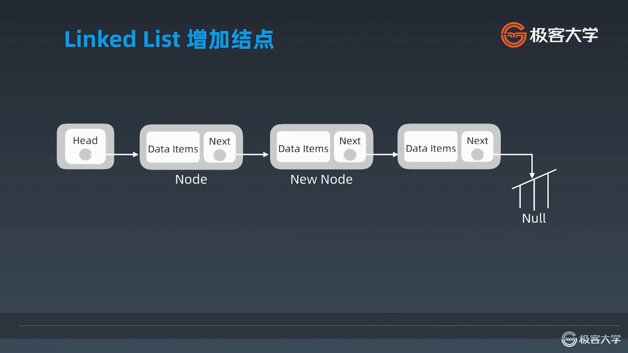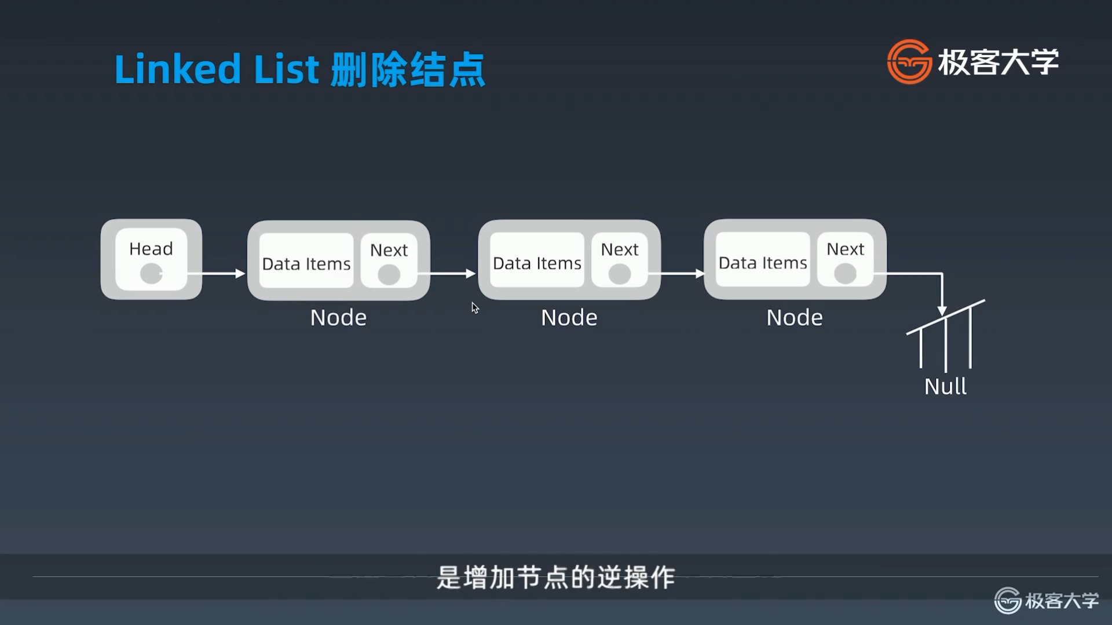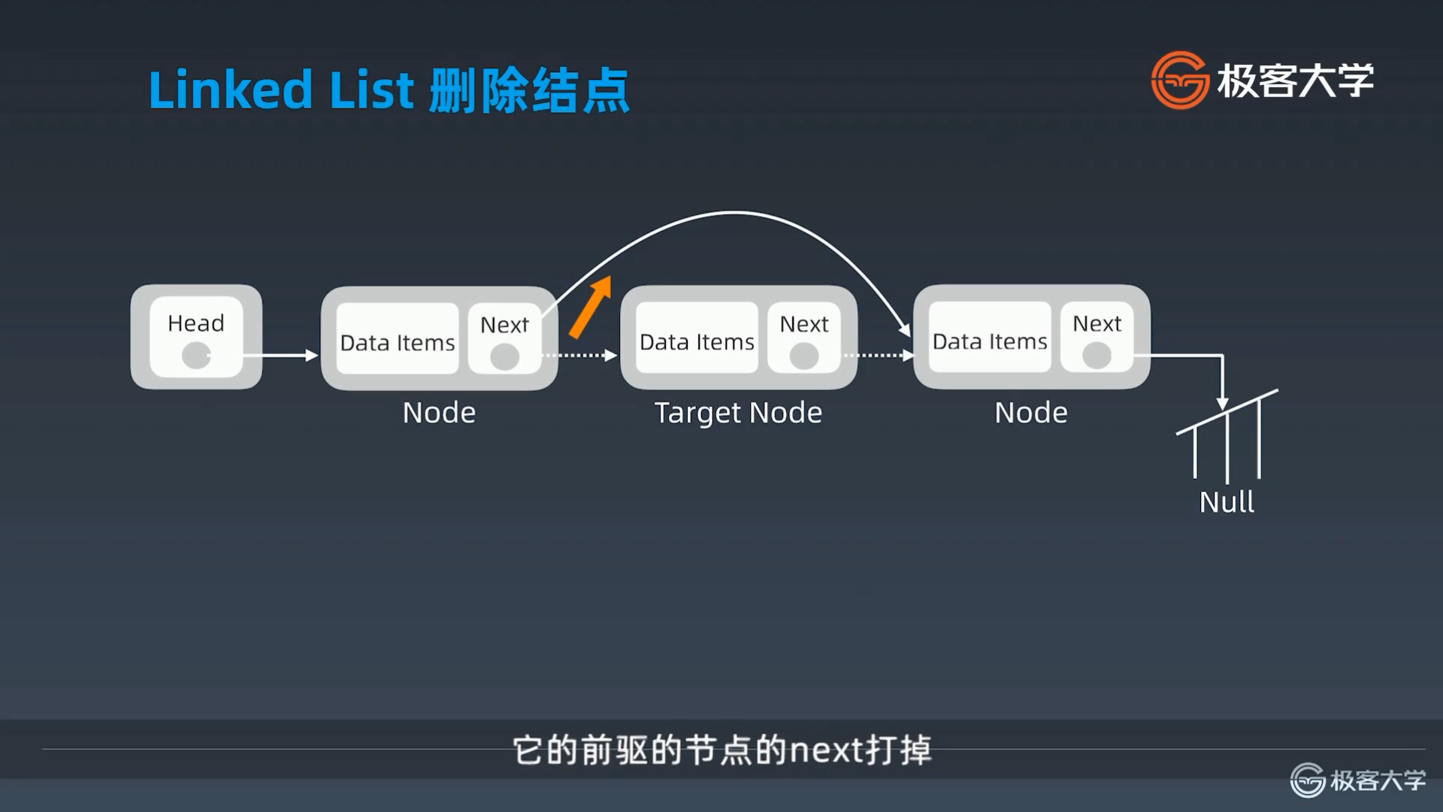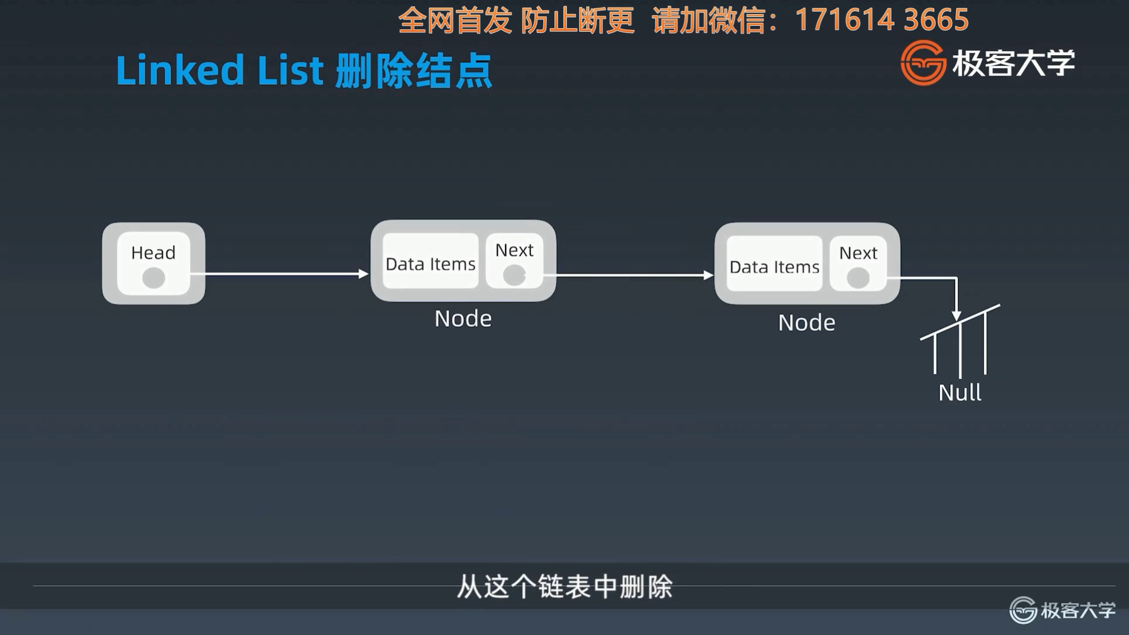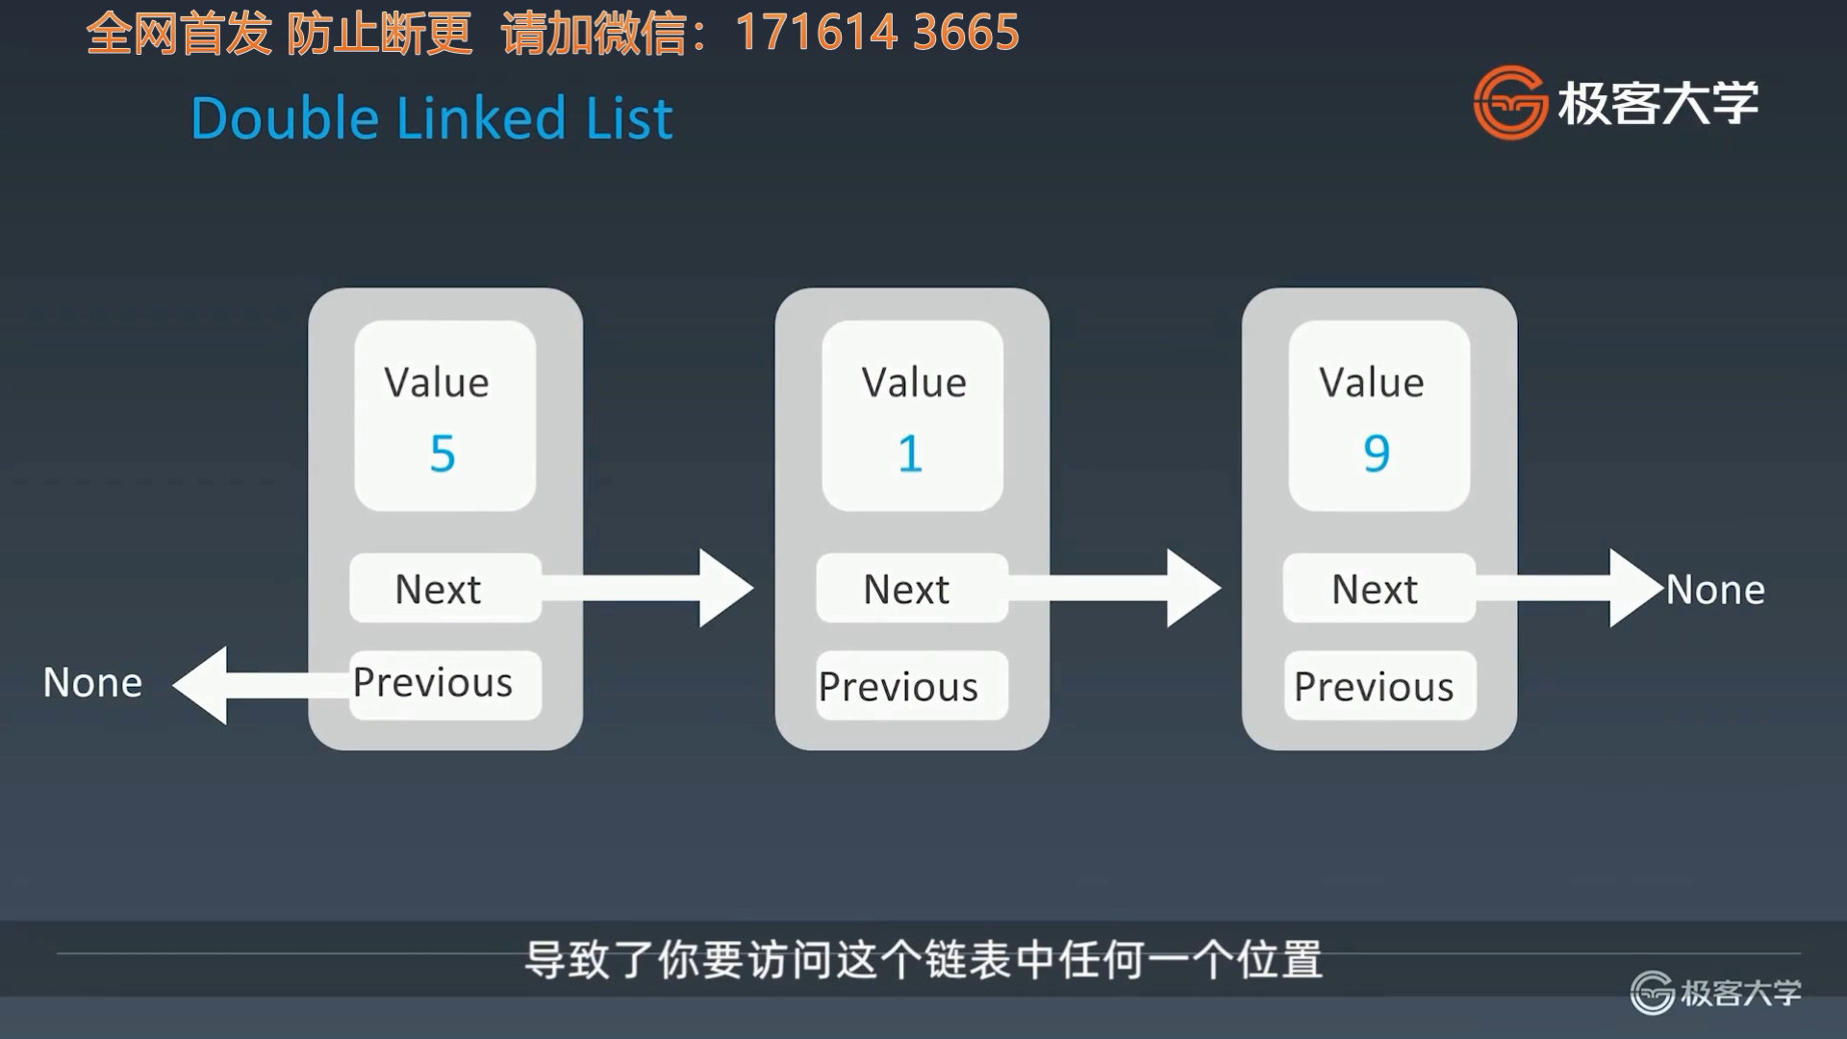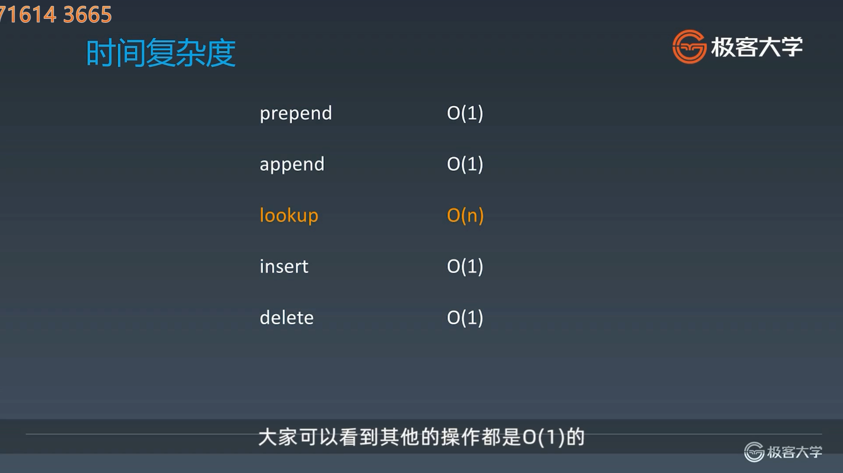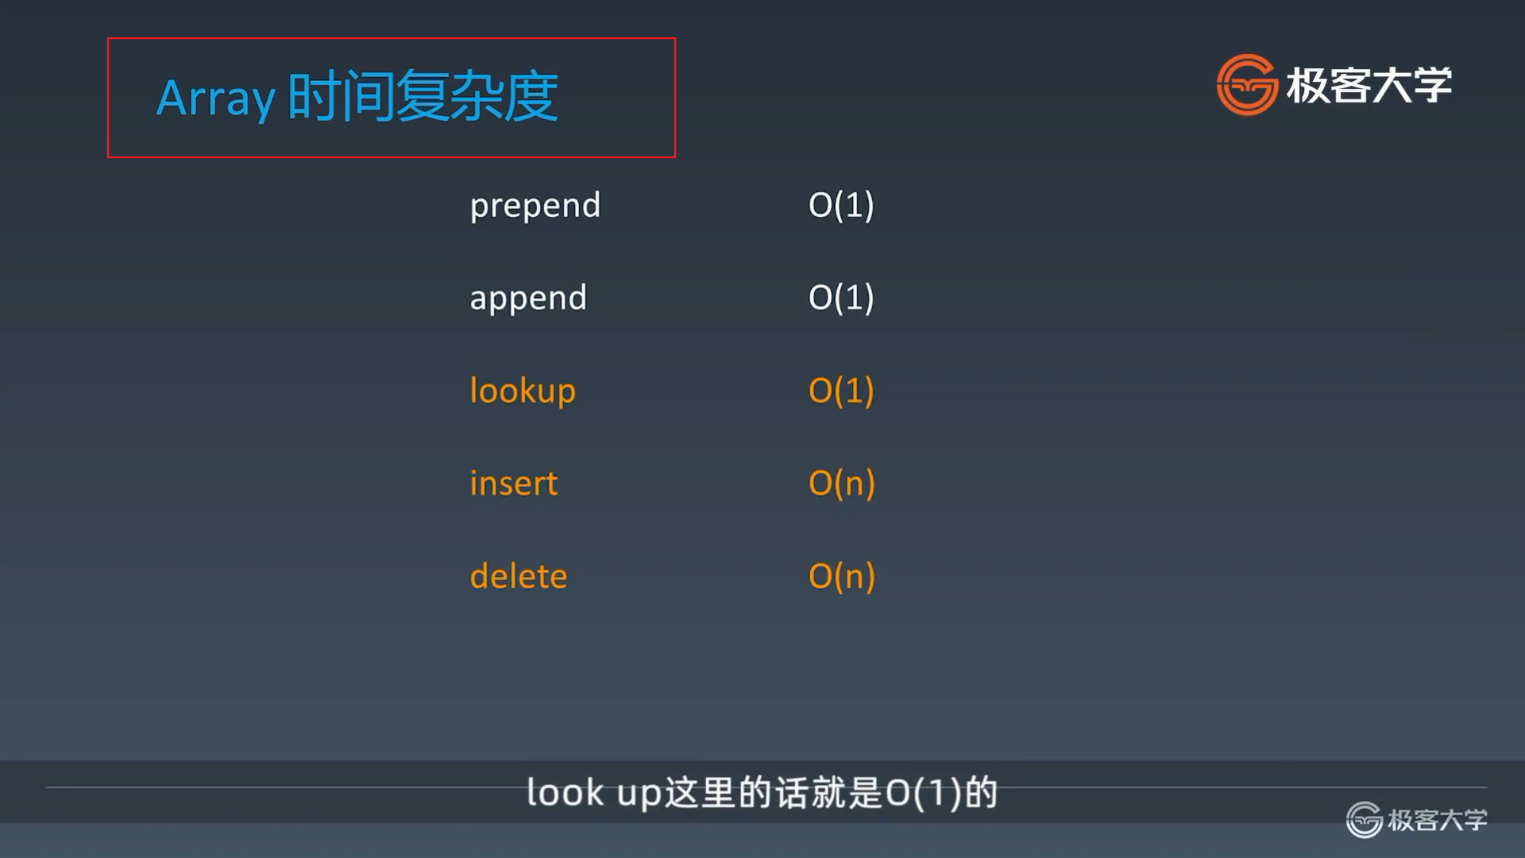

## 工程中Redis使用跳表 参考链接

* [Java 源码分析（ArrayList）](http://developer.classpath.org/doc/java/util/ArrayList-source.html)
* [Linked List 的标准实现代码](http://www.geeksforgeeks.org/implementing-a-linked-list-in-java-using-class/)
* [Linked List 示例代码](http://www.cs.cmu.edu/~adamchik/15-121/lectures/Linked%20Lists/code/LinkedList.java)
* [Java 源码分析（LinkedList）](http://developer.classpath.org/doc/java/util/LinkedList-source.html)
* LRU Cache - Linked list：[LRU 缓存机制](http://leetcode-cn.com/problems/lru-cache)
* Redis - Skip List：[跳跃表](http://redisbook.readthedocs.io/en/latest/internal-datastruct/skiplist.html)、[为啥 Redis 使用跳表（Skip List）而不是使用 Red-Black？](http://www.zhihu.com/question/20202931)

两数之和题目：<https://leetcode-cn.com/problems/two-sum/>

## Array 实战题目

* <https://leetcode-cn.com/problems/container-with-most-water/>
* <https://leetcode-cn.com/problems/move-zeroes/>
* <https://leetcode.com/problems/climbing-stairs/>
* <https://leetcode-cn.com/problems/3sum/>(高频老题）

## Linked List 实战题目

* <https://leetcode.com/problems/reverse-linked-list/>
* <https://leetcode.com/problems/swap-nodes-in-pairs>
* <https://leetcode.com/problems/linked-list-cycle>
* <https://leetcode.com/problems/linked-list-cycle-ii>
* <https://leetcode.com/problems/reverse-nodes-in-k-group/>

## 课后作业

* <https://leetcode-cn.com/problems/remove-duplicates-from-sorted-array/>
* <https://leetcode-cn.com/problems/rotate-array/>
* <https://leetcode-cn.com/problems/merge-two-sorted-lists/>
* <https://leetcode-cn.com/problems/merge-sorted-array/>
* <https://leetcode-cn.com/problems/two-sum/>
* <https://leetcode-cn.com/problems/move-zeroes/>
* <https://leetcode-cn.com/problems/plus-one/>

[戳此了解每周课后作业要求及提交方式](http://u.geekbang.org/lesson/1?article=144228)



283移动零

O(n)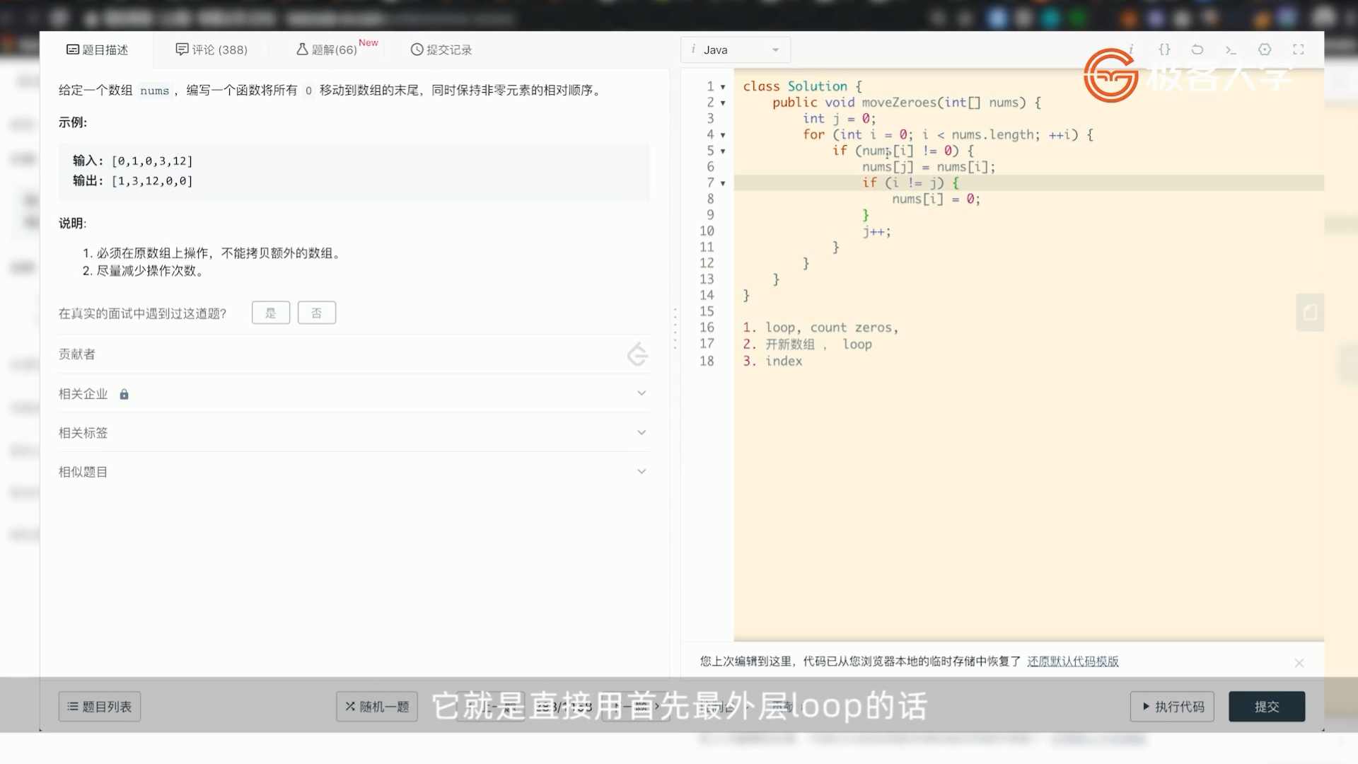

11盛水最多的容器

O(n^2)

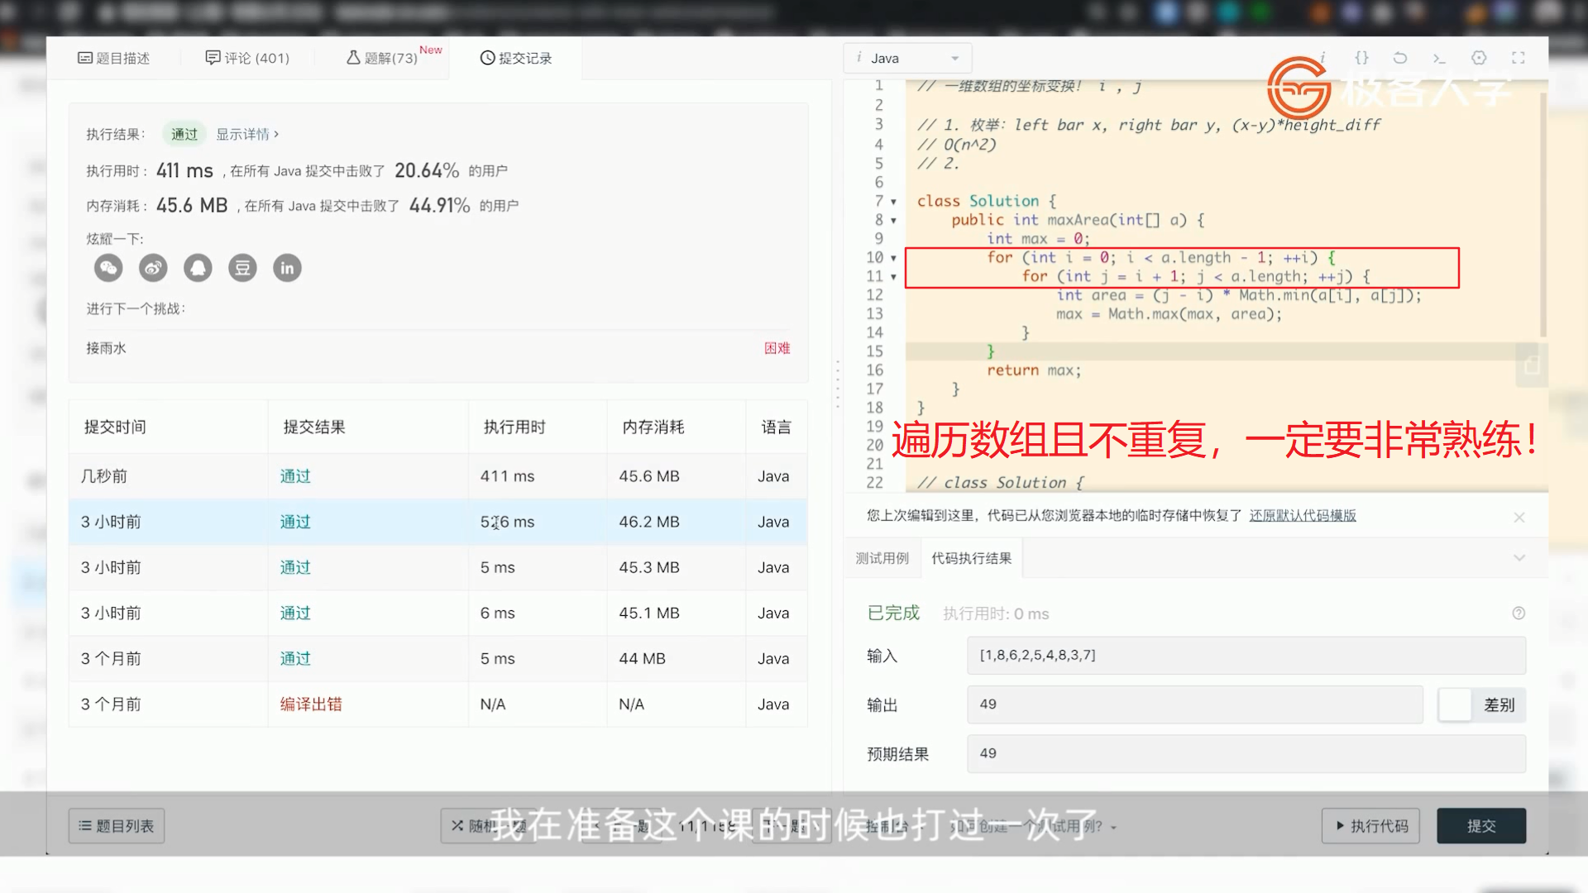 O(n)

## 

70爬楼梯

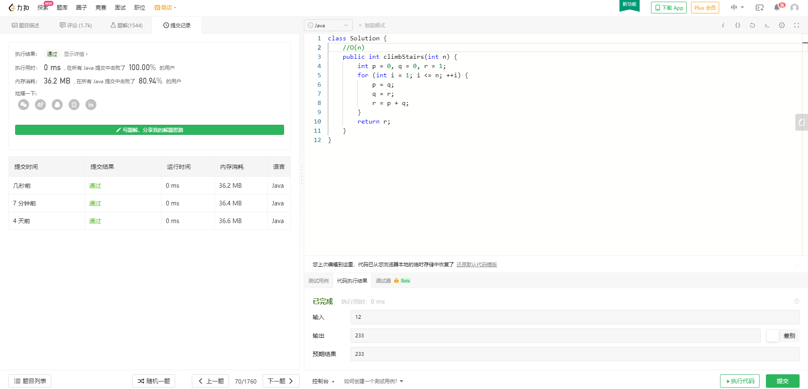

1 两数之和

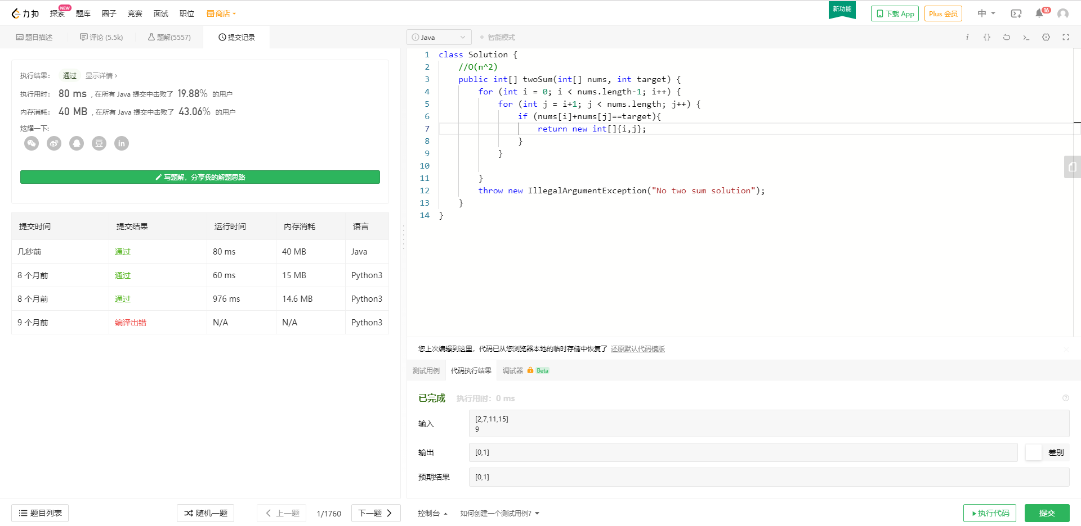15 三数之和

双指针O(n^2)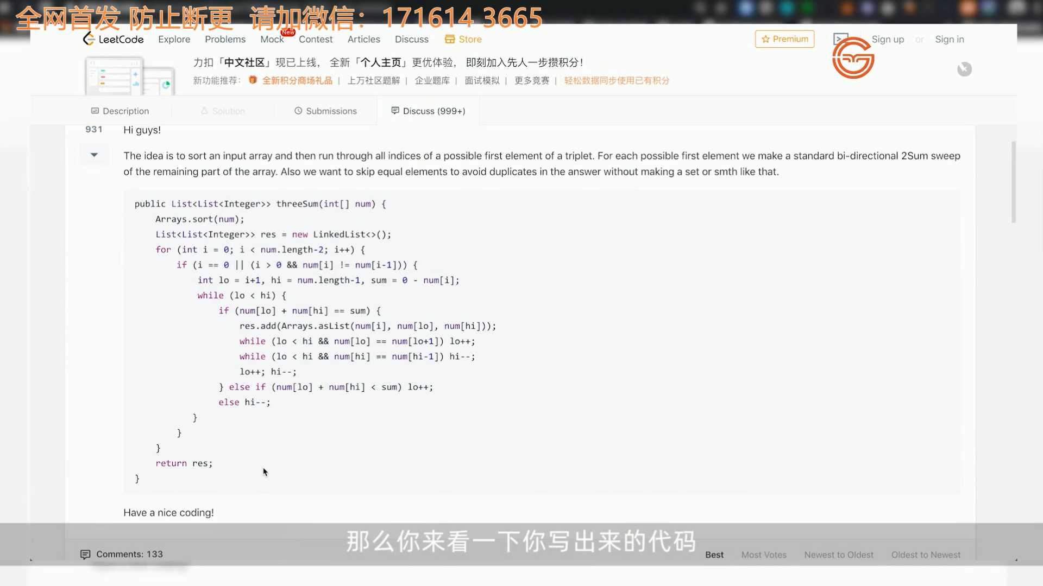

206反转链表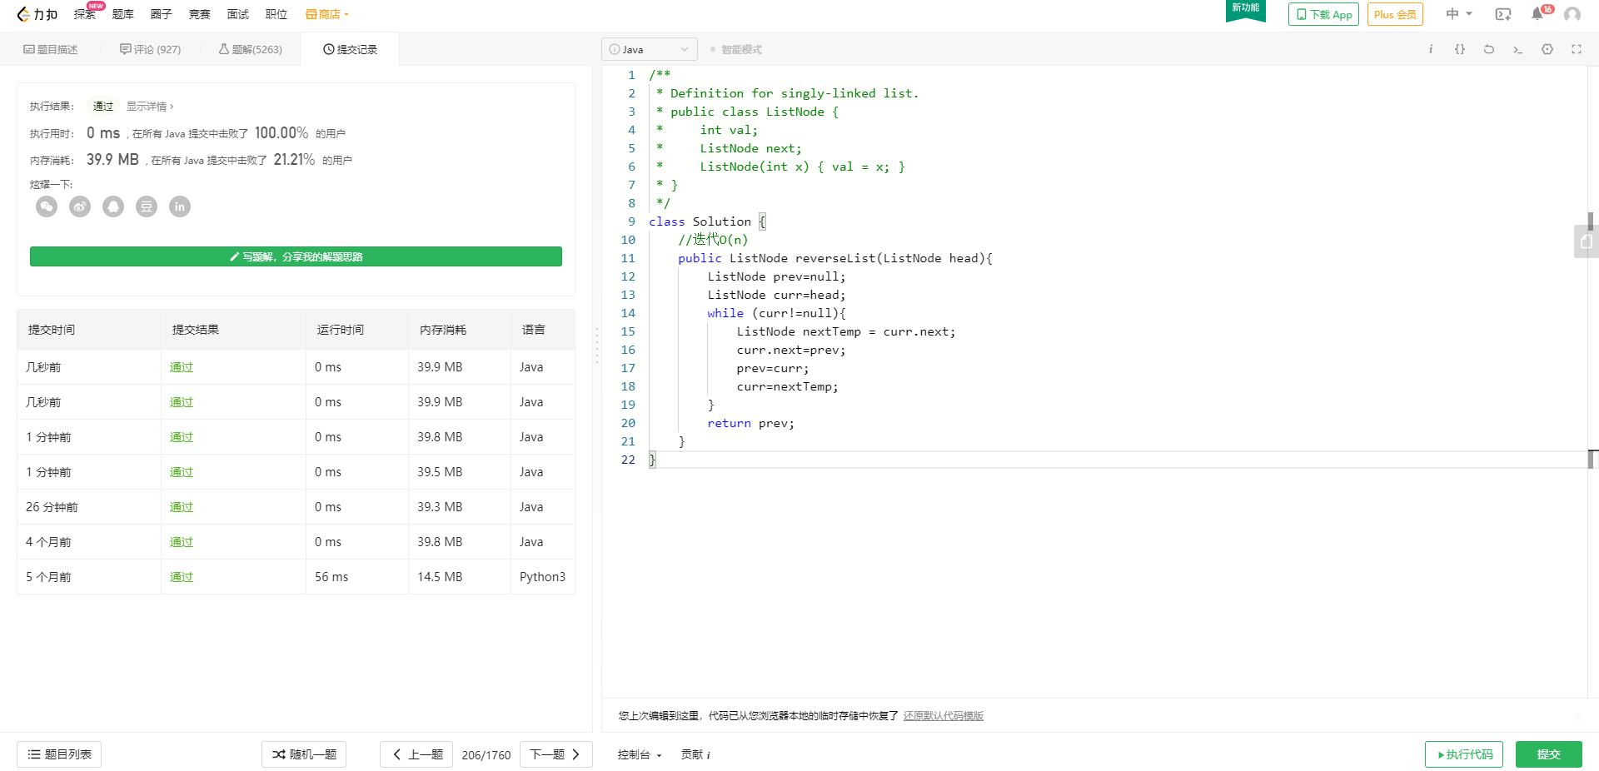 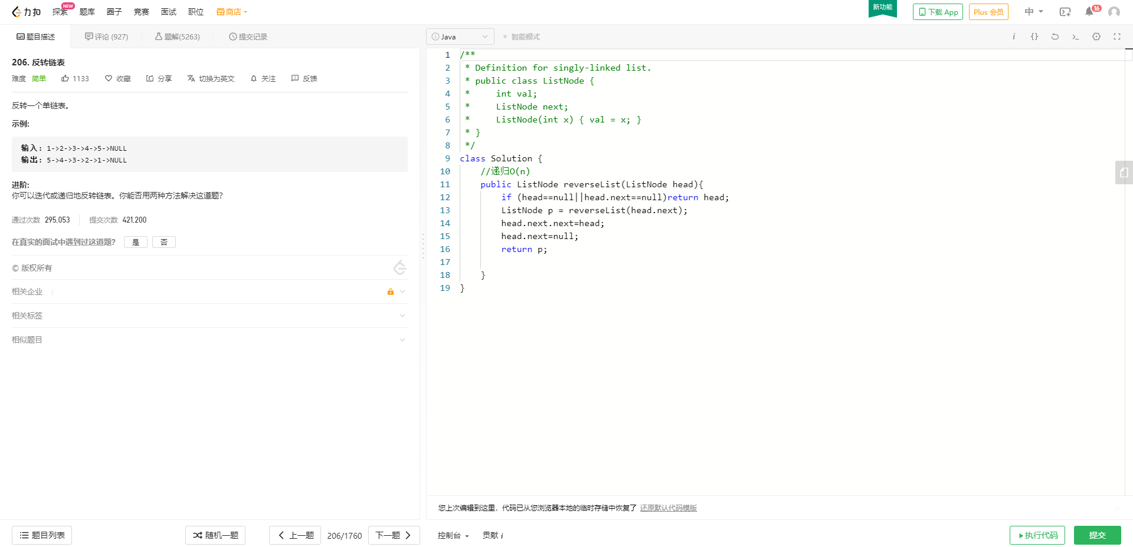

141环形链表

快慢指针

